**Summer Camp**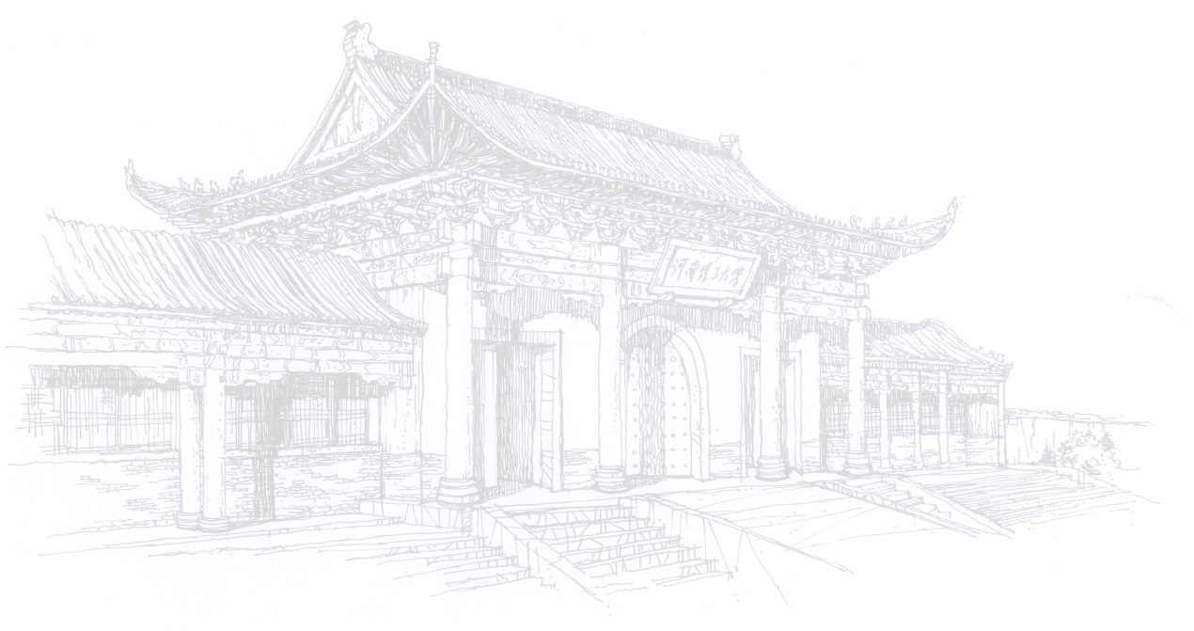

**Held by Henan Polytechnic University, China**

1. **Outline**

* Time: 6 days from 14th -19th August, 2025 (to be confirmed)
* **Location:** 2001 Century Road, Jiaozuo City, Henan Province, China
* **Main contents:** courses and activities including Chinese language, Taiji, calligraphy, and cultural tours
* **Participants: 20** students in total from sister universities of HPU; **1-2** participant for each university.

**2. Fees and Sponsorship**

HPU will cover the following expenses for every participant, including the accommodation, meals, local transportation and short-term accident insurance during their stay in the summer camp.

Participants are responsible for their own visa application fees, international airfare, travel insurance and other personal expenses, not limited to the above mentioned.

1. **Application**
2. **Deadline:** Please send us the information before July **1st**, 2025
3. Number of students applying for the Camp;
4. and their application forms.
5. Even if there are no students who are interested in the Camp, please also let us know.

**Note:** HPU only accepts the official feedback from the home university, and does NOT accept the direct application from the students.

1. **Online-interview.** HPU and the home university will organize an interview for applicants in **early July.**

Attachment 1 Tentative Schedule

Attachment 2 Application form for HPU Summer Camp

**Attachment 1**

**Tentative Schedule**

|  |  |  |
| --- | --- | --- |
| **Date** | **Time** | **Activity** |
| Day 1 | all day  (08:00~18:00) | Arrive in Jiaozuo, Henan |
| Day 2 | morning  (08:30~11:30) | Chinese Language |
| afternoon  (15:00~18:00) | Learning Chen style Taijiquan |
| Day 3 | morning  (08:30~11:30) | Introduction to China  Visit China Contemporary Water Conservancy Project Construction–Museum of South-to-North Water Diversion Project in Jiaozuo |
| afternoon  (15:00~18:00) | Introduction to China  Visit Chenjiagou Village—the birthplace of Taijiquan |
| Day 4 | all day  (09:00~17:00) | Visit the National Museum of Chinese Writing in Anyang |
| Day 5 | all day  (09:00~17:00) | Visit the Diecai Cave Cultural and Educational Base & Global Geopark |
| Day 6 | morning  (08:30~11:30) | Closing Ceremony |
| afternoon  (14:00~20:00) | Departure |

**Attachment 2**

**Application Form**

**for HPU Summer Camp**

|  |  |  |  |  |  |  |  |  |  |  |
| --- | --- | --- | --- | --- | --- | --- | --- | --- | --- | --- |
| Full Name | |  | | | | | Photo | | | |
| Date of Birth | |  | | | | |
| Age | |  | | | | |
| Nationality | |  | | | | |
| Gender | |  | | | | |
| **Learning Experience** | | | | | | | | | | |
| Name of University | |  | | | | | | | | |
| Major | |  | | Year of Class | | | | |  | |
| Have you ever learned Chinese? | | □fluent □moderate □basic □none | | | | | | | | |
| Have you ever been to China? If yes, when and where? | |  | | | | | | | | |
| Have you ever heard of Taijiquan (Tai Chi)? | | □Yes □No | | | | | | | | |
| **Contact Information** | | | | | | | | | | |
| Personal Information | Passport No. | |  | | Valid Until | | | | |  |
| Mobile Number | |  | | | | | | | |
| E-mail | |  | | | | | | | |
| Emergency Contact  Information | Name | |  | | | Relation | |  | | |
| Mobile Number | |  | | | Fax | |  | | |
| Email | |  | | | | | | | |