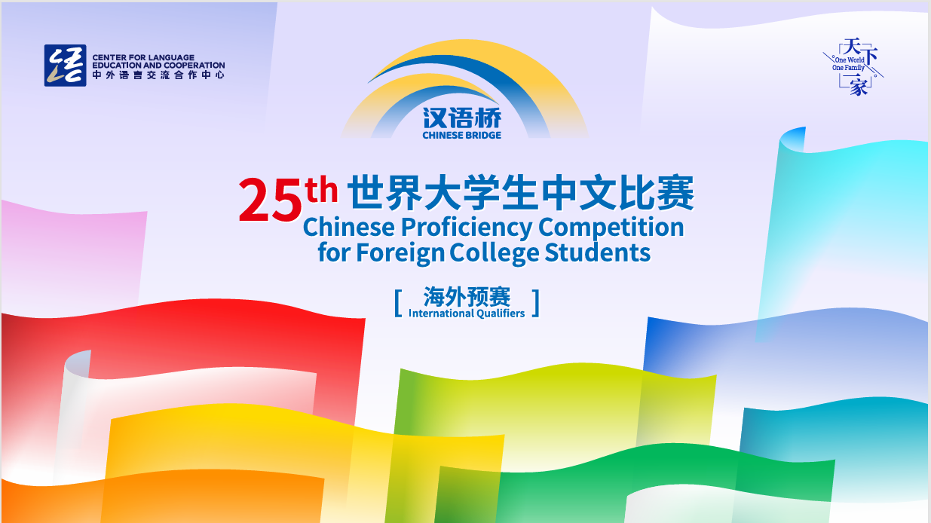
The 25th “Chinese Bridge”
Chinese Proficiency Competition for Foreign Tertiary Students
The South Island Regional 2026
The "Chinese Bridge" Chinese Proficiency Competition aims to inspire students' enthusiasm for learning Chinese and enhance their understanding of Chinese language and culture.
Category:
Tertiary Students Category (Participants aged 18–30, born between September 1, 1995, and August 31, 2007, are eligible to participate.)
Eligibility of Participants:
According to the regulations set by the Centre for Language Education and Cooperation, students representing New Zealand in the International Competition in China must meet the following criteria:
i. Be a New Zealand citizen or New Zealand permanent resident (must not hold Chinese citizenship).
ii. Have been raised in countries or regions outside of China.
iii. Not have Chinese as their first language. Neither parent may be a native speaker of Chinese.
iv. Be full-time students enrolled at a school in the South Island of New Zealand.

In principle, participants who have competed in the previous Global Finals are not permitted to participate in the same competition for two consecutive years.
For any questions regarding eligibility, they should be addressed to the organising committee (For more information about how to do this, please contact Xiaolu Chen xiaolu.chen@canterbury.ac.nz). The organising committee will decide based on the available information. The committee’s decision is final.

Registration Deadline for Regional Competition: (1st May 2026)
submit the Letter of Authorisation (Attachment 1) to Xiaolu Chen(xiaolu.chen@canterbury.ac.nz) by 1st May 2026
Topic:
天下一家 (One world, One family)
Time and Venues
 | Time and date | Venue | City
Final Competition | Starting time: 10am  Saturday 30th May | University of Canterbury  (Central Lecture Theatre:C1\C2\C3) | Christchurch
The total duration and programme arrangement of the competition shall be determined in accordance with the number of participants.

Format of the Competition:
- Tertiary Category

The Competition comprises two sections: Chinese Speech and Talent Presentation. Participants are encouraged to wear traditional Chinese costumes or other traditional Chinese garments of their preference. School uniforms should not be worn during the competition.

- Chinese Speech: Each student is required to deliver a speech not exceeding 5 minutes in length. There is no minimum time requirement. Students are encouraged to use props or other forms of demonstration to enrich their presentations. It is not recommended that students simply read from a prewritten script. Speeches will be assessed based on content, presentation skills, pronunciation, and grammatical accuracy. This component constitutes 80% of the overall score.
- Talent presentation: Each student is required to present one performance showcasing a Chinese cultural art form, including but not limited to singing Chinese songs, instrumental performance, dance, acrobatics, calligraphy, painting, paper-cutting, martial arts, or other traditional or contemporary Chinese artistic expressions. Performances will be assessed on artistic merit, creativity, and overall impact. This component constitutes 20% of the overall score.

Judging Criteria for the Tertiary Category
Sections | 1) Chinese Speech |  |  |  | 2) Talent | Total
Judging Criteria | Content  20% | Presentation  30% | Pronunciation  20% | Vocabulary and Grammar  10% | Artistry /  Appeal /  Complexity  20% | Language Part+  Talent
Percentage | 80% (Language Part) |  |  |  | 20% | 100%
Ranking Priority | 2 |  |  |  | 3 | 1

Awards:
Prizes and certificates will be awarded according to each student’s ranking in the competition. After the competition, following qualification verification by the Chinese Bridge New Zealand South Island Organizing Committee, one contestant will be recommended to travel to China to represent New Zealand in the Chinese Bridge Chinese Proficiency International Competition later this year, and another winning contestant is allowed to visit China to observe the competition. All expenses for the selected contestants’ travel to China shall be covered by the Organizing Committee of the global competition, with event time and location to be confirmed. These contestants will be notified in writing following the conclusion of the South Island Competition.

For further inquiries, please email Xiaolu Chen, Confucius Institute at the University of Canterbury at xiaolu.chen@canterbury.ac.nz.
More information about the “Chinese Bridge” Competition is available at http://bridge.chinese.cn.
--------------------------------------------------------------------------------------------------------------------------------------
Attachment 1:

