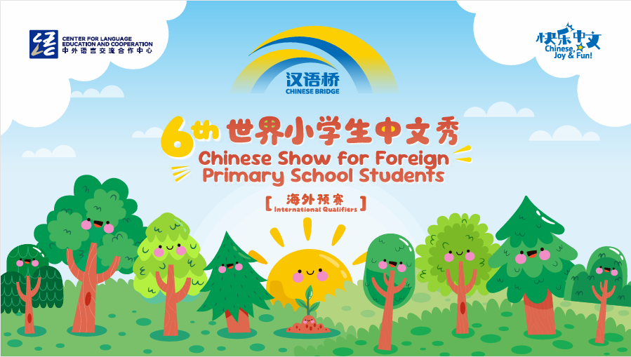

The 6th “Chinese Bridge” - Chinese Proficiency Competition for
Foreign Primary School Students
The South Island Regional Competition 2026

The "Chinese Bridge" Chinese Proficiency Competition aims to encourage students in learning Chinese and deepen their understanding of Chinese language and culture.
Categories:
- Primary Category （age 6-12, born on or after September 1, 2013, are eligible to participate. ）
Eligibility of Participants:
In accordance with the Centre for Language Education and Cooperation (CLEC) regulations, students representing New Zealand in the International Competition in China must meet the following criteria:
i. Be a New Zealand citizen or New Zealand permanent resident (must not hold Chinese citizenship).
ii. Have been raised in countries or regions outside of China.
iii. Not have Chinese as their first language. Neither parent may be a native speaker of Chinese.
iv. Be a full-time student enrolled at a school in the South Island of New Zealand.
In principle, participants who have competed in the previous Global Finals are not permitted to participate in the same competition for two consecutive years.
For any questions regarding eligibility, they should be addressed to the organising committee (For more information about how to do this, please contact Xiaolu Chen xiaolu.chen@canterbury.ac.nz). The organising committee will decide based on the available information. The committee’s decision is final. Should any candidate be found ineligible during the competition, they will be disqualified.

Registration Deadline for Regional Competition: (1st May 2026)
Submit Letter of Authorisation (Attachment 1))to Xiaolu Chen (xiaolu.chen@canterbury.ac.nz) by 1st May 2026

Topic:
快乐中文 (Chinese, Joy & Fun)
Time and Venues for Regional Competitions:

 | Time and date | Venue | City
South Island Final | Starting time:10am  Saturday 30th May | University of Canterbury  (Central Lecture Theatre:C1\C2\C3) | Christchurch
The total duration and programme arrangement of the competition shall be determined in accordance with the number of participants.
Format of the Competition:
- Primary Category
The Competition consists of two sections: Chinese Speech and Talent Presentation. Contestants are encouraged to wear traditional Chinese costumes, or their own traditional dresses if desired. Students are asked not to wear their school uniforms.

- Chinese Speech: Each student is required to deliver a speech not exceeding 5 minutes in length. There is no minimum time requirement. Students are encouraged to use props or other forms of demonstration to enrich their presentations. It is not recommended that students simply read from a prewritten script. Speeches will be assessed based on content, presentation skills, pronunciation, and grammatical accuracy. This component constitutes 80% of the overall score.
- Talent presentation: Each student is required to present one performance showcasing a Chinese cultural art form, including but not limited to singing Chinese songs, instrumental performance, dance, acrobatics, calligraphy, painting, paper-cutting, martial arts, or other traditional or contemporary Chinese artistic expressions. Performances will be assessed on artistic merit, creativity, and overall impact. This component constitutes 20% of the overall score.

Judging Criteria for the Junior Category
Sections | 1) Chinese Speech |  |  |  | 2) Talent | Total
Judging Criteria | Content  20% | Presentation  30% | Pronunciation  20% | Vocabulary and Grammar  10% | Artistry /  Appeal /  Complexity  20% | Language Part+  Talent
Percentage | 80% (Language Part) |  |  |  | 20% | 100%
Ranking Priority | 2 |  |  |  | 3 | 1

School Representatives for the South Island Competition:
Schools or institutions are responsible for conducting their own selection process before the competition in Christchurch. CIUC encourages integrating competition activities into classroom learning. Each school may nominate up to five representatives in the Primary Category.
Prizes for South Island Competition:
Prizes and certificates will be issued according to each student’s ranking in the competition.
After the competition, following qualification verification by the Chinese Bridge New Zealand South Island Organizing Committee, one contestant will be recommended to travel to China, to represent New Zealand in the Chinese Bridge Chinese Proficiency International Competition later this year (event location and time to be confirmed). The selected contestant will receive official written notification following the South Island competition. All expenses for the selected contestant’s travel to China will be covered by the organizing committee of the global competition. A contestant under the age of 18 may be accompanied by one authorized guardian (teacher or parent) who will assume guardianship responsibilities and share accommodations with the contestant. Proper authorization needs to be arranged through their schools prior to the travel.
For further inquiries, please contact Xiaolu Chen from CIUC at xiaolu.chen@canterbury.ac.nz
More information about the “Chinese Bridge” Competition is available at http://bridge.chinese.cn.
--------------------------------------------------------------------------------------------------------------------------------------
Attachment 1:

