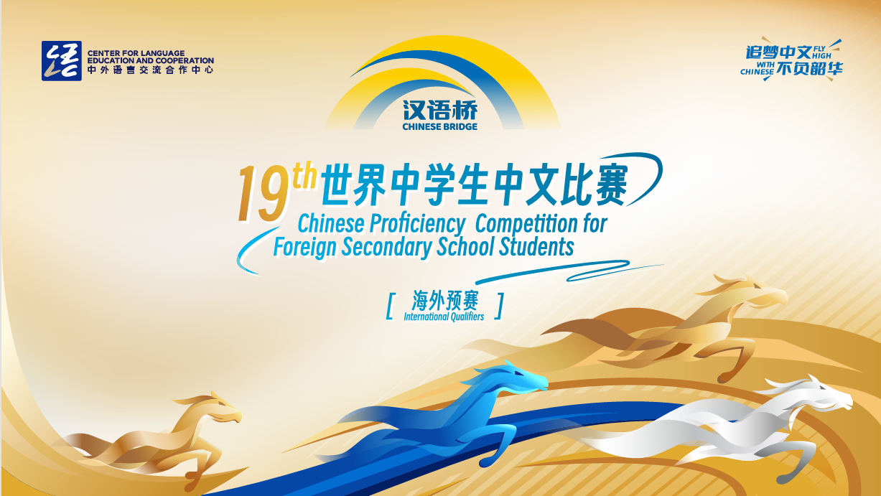
The 19th “Chinese Bridge” - Chinese Proficiency Competition
for Foreign Secondary School Students
The South Island Regional 2026
The "Chinese Bridge" Chinese Proficiency Competition aims to encourage students in learning Chinese and deepen their understanding of Chinese language and culture.
Categories:
- Secondary Category (Junior: Year 9-10)
- Secondary Category (Senior: Year 11-13)
(Participants aged 12–18, born between September 1, 2007, and August 31, 2013, are eligible to participate.)
Eligibility of Participants:
According to regulations set by the Centre for Language Education and Cooperation (CLEC), students representing New Zealand in the International Competition in China must meet the following criteria:
i. Be a New Zealand citizen or New Zealand permanent resident (must not hold Chinese citizenship).
ii. Have been raised in countries or regions outside of China.
iii. Not have Chinese as their first language. Neither parent may be a native speaker of Chinese.
iv. Be full-time students enrolled at a school in the South Island of New Zealand.

In principle, participants who have competed in the previous Global Finals are not permitted to participate in the same competition for two consecutive years.
For any questions regarding eligibility, they should be addressed to the organising committee (For more information about how to do this, please contact Xiaolu Chen xiaolu.chen@canterbury.ac.nz). The organising committee will decide based on the available information. The committee’s decision is final. Should any candidate be found ineligible during the competition, they will be disqualified.

Registration Deadline for Regional Competition: (1st May 2026)
Submit Letter of Authorisation (Attachment 1) to Xiaolu Chen(xiaolu.chen@canterbury.ac.nz) by 1st May 2026
Topic:
追梦中文，不负韶华 (Fly high with Chinese)
Time and Venues for Regional Competitions:
 | Time and date | Venue | City
South Island Final | Starting time: 10am  Saturday 30th May | University of Canterbury  (Central Lecture Theatre:C1\C2\C3) | Christchurch
The total duration and programme arrangement of the competition shall be determined in accordance with the number of participants.

Format of the Competition:
- Secondary Category (Junior: Year 9-10)
Chinese speech (2 - 3 minutes) + Talent presentation (up to 3 minutes)

- Secondary Category (Senior: Year 11-13)
Chinese speech (2 - 3 minutes) + Q&A session + Talent presentation (up to 3 minutes)

Secondary Category (Junior: Year 9-10)
The Competition consists of two sections: Chinese Speech and Talent Presentation. Contestants are encouraged to wear traditional Chinese costumes, or their own Chinese traditional dresses if desired. Students are asked to not wear their school uniforms.
- Chinese Speech: Each student is required to deliver a speech not exceeding 5 minutes in length. There is no minimum time requirement. Students are encouraged to use props or other forms of demonstration to enrich their presentations. It is not recommended that students simply read from a prewritten script. Speeches will be assessed based on content, presentation skills, pronunciation, and grammatical accuracy. This component constitutes 80% of the overall score.
- Talent presentation: Each student is required to present one performance showcasing a Chinese cultural art form, including but not limited to singing Chinese songs, instrumental performance, dance, acrobatics, calligraphy, painting, paper-cutting, martial arts, or other traditional or contemporary Chinese artistic expressions. Performances will be assessed on artistic merit, creativity, and overall impact. This component constitutes 20% of the overall score.
Judging Criteria for the Junior Category
Sections | 1) Chinese Speech |  |  |  | 2) Talent | Total
Judging Criteria | Content  20% | Presentation  30% | Pronunciation  20% | Vocabulary and Grammar  10% | Artistry /  Appeal /  Complexity  10% | Language Part+  Talent
Percentage | 80% (Language Part) |  |  |  | 20% | 100%
Ranking Priority | 2 |  |  |  | 3 | 1

Secondary Category (Senior: Year 11-13)
The Competition consists of three sections: Chinese Language Speech, Question and Answer session and a Talent Presentation. Contestants are encouraged to wear traditional Chinese costumes, or their own traditional dresses if desired. Students are asked to not wear their school uniforms.

- Chinese Speech: Each student is required to deliver a speech not exceeding 5 minutes in length. There is no minimum time requirement. Students are encouraged to use props or other forms of demonstration to enrich their presentations. It is not recommended that students simply read from a prewritten script. Speeches will be assessed based on content, presentation skills, pronunciation, and grammatical accuracy. This component constitutes 80% of the overall score.
- Q & A : Immediately after the speech, the student will select a pre-prepared question from a pool (Attachment 2) and answer it in Chinese. One of the judges will then ask for more details from the contestants, which should be answered in Chinese. The question list will be provided to all contestants in advance. This makes up 10% of the total score.
- Talent Presentation: Each student is required to present one performance showcasing a Chinese cultural art form, including but not limited to singing Chinese songs, instrumental performance, dance, acrobatics, calligraphy, painting, paper-cutting, martial arts, or other traditional or contemporary Chinese artistic expressions. Performances will be assessed on artistic merit, creativity, and overall impact. This component constitutes 20% of the overall score.

Judging Criteria for the Senior Category
Sections | 1) Chinese Speech |  |  |  | 2) Q&A | 3) Talent | Total
Judging Criteria | Content  20% | Delivery  20% | Pronunciation  20% | Vocabulary and Grammar  10% | Accuracy / Completeness /Reaction  Speed  10% | Artistry /  Appeal /  Complexity  10% | Language Part+  Talent
Percentage | 80% (Language Part) |  |  |  | 10% | 10% | 100%

School Representatives for the South Island Competition:
A single South Island competition will be held in Christchurch, with no regional preliminary rounds.
Schools or institutions are responsible for conducting their own selection process before the competition. CIUC encourages integrating competition activities into classroom learning so that all students are given equal opportunities. Each school may nominate up to six representatives for the Senior and Junior groups of the Secondary Student Category, respectively.
Prizes for South Island Competition:
- Prizes and certificates will be issued according to each student’s placing in the competition.
- Following the competition and qualification verification by the Chinese Bridge New Zealand South Island Organizing Committee, one contestant will be selected to represent New Zealand at the Chinese Bridge Chinese Proficiency International Competition in China later this year. All expenses for traveling to China will be covered (event days and locations to be confirmed). The selected contestant will receive official written notification after the conclusion of the South Island Competition.
- Contestants under the age of 18 may be accompanied by one authorized guardian to China, who will assume guardianship responsibilities and share accommodations with the contestant. Proper authorization needs to be arranged through their schools prior to the travel.
For further inquiries, please contact Xiaolu Chen from CIUC at xiaolu.chen@canterbury.ac.nz
More information about the “Chinese Bridge” Competition is available at http://bridge.chinese.cn.
--------------------------------------------------------------------------------------------------------------------------------------
Attachment 1:

Attachment 2:

